**How to create a Java project (with dependent jar files) in Eclipse**  
o “File > New > Project > Java > Java Project”  
- Give your project a name:  
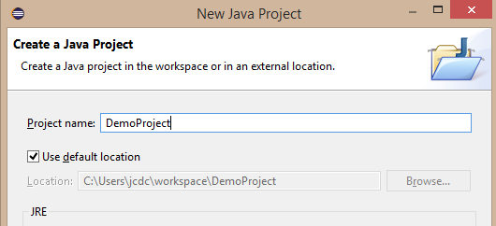  
- Click the “Finish” button.  
  
o Add a class.  
- Right-click on the project name…  
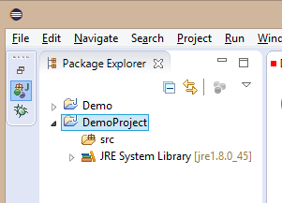  
- …and select “New > Class”.   
  
o Specify the class name “HelloWorld”, and it’s also a good idea to include a package name:  
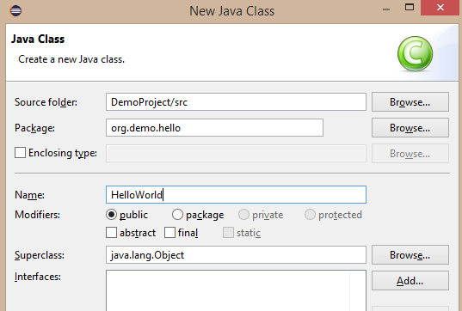  
  
o Click the “Finish” button. You should see the following:  
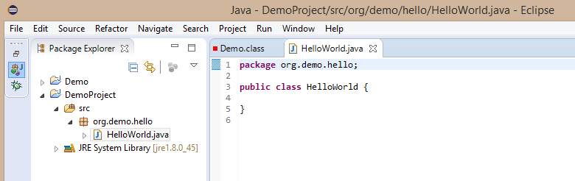  
  
**NOTE**: The class directory structure is created automatically:  
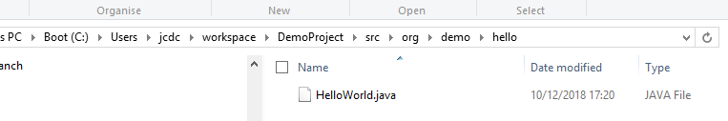

o “Run > Run Configurations…”  
Here we need to point to the main class:  
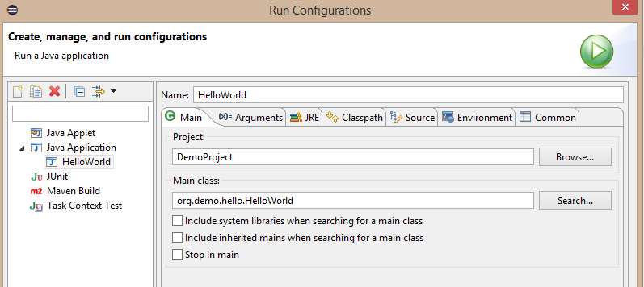  
Click the “Run” button.

o To add existing source files.  
- Copy the files to the correct sub-dirs of “workspace/src”.   
- Right-click on “src” under the project name, and click “Refresh”. The sources should be imported:  
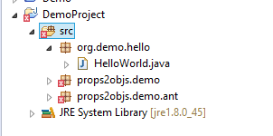  
If little red crosses appear next to lines in the code referring to the source level:  
- Open “Project > Properties > Java Compiler”.  
- Tick “Enable project specific settings”.  
- Select the target Java version using the pulldown “Compiler compliance level”.

o To add existing jar files to the project.  
- Right-click on the project name and select “New > Folder”. Give it the name “jars”.  
This will create the folder “workspace/DemoProject/jars”.   
- Copy your jar files into this directory.  
- Select “Project > Properties > Java Build Path”.  
- Select “Libraries” tab.  
- Click “Add Jars…”  
- Tick the “jars” directory we added earlier to the project.  
- In the project tree view, right-click on the new “jars” folder and click “Refresh”. The jar files should now be listed:  
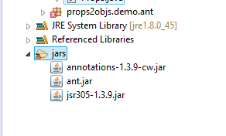  
- Select all of the jar files, right-click and select: “Build Path > Add to Build Path”:  
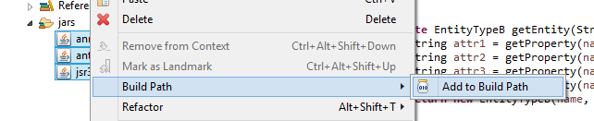  
  
*JeremyC 10-12-2018***END**